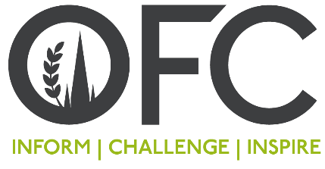

Press Release
09 December 2020

Henry Dimbleby, branding UK agriculture and the red meat fight-back to headline at OFC 2020

The headlines that red meat is damaging to the health is not the whole story, according to Professor Alice Stanton who will be giving the Science Lecture at the 2020 Oxford Farming Conference (OFC) which runs from 7-9 January.

Joining the leading human health scientist will be Henry Dimbleby, founder of Leon and mastermind of the UK’s national food strategy and Poran Malani, a global ‘ad man’ who works with Sir Martin Sorrell on some of the world's best-known brands.

In a very strong line-up of speakers, the Defra Secretary of State and the Shadow Secretary of State will join NFU President Minette Batters and Craig Bennett, CEO of Friends of the Earth in the first post-election debate following the election.

Commenting on the speakers, Matthew Naylor, a Lincolnshire farmer and Chair of the 2020 Conference says:
“For the first time almost 50 years, farmers in the United Kingdom will be working under a repatriated agricultural bill and, with the loss of direct payments and new foreign competition, they face a decade of change. We are delving into society’s challenges to find the opportunities for farming businesses.”
The conference will debate how can agriculture can balance a low carbon economy with healthy, nutritious, affordable food, as well as exploring the opportunities to harness the power of food to unite urban consumers with farmers.

“We’ll also talk about how farmers could diversify into other services for society to provide solutions to national challenges such as obesity and mental health, in partnership with, for example, the NHS.”

In what is likely to be a hotly engaged with session on red meat, Professor Stanton, a clinician-scientist in Cardiovascular Pharmacology at the Royal College of Surgeons in Ireland, will explain the scientist’s perspective.

“Red meat has been linked to a higher incidence of cardiovascular diseases such as high blood pressure, and to certain cancers; what should be communicated is that red meat is good, in moderation."

Professor Stanton will centre her speech around diet and human health, however, with her strong understanding of meat production and farming practices, she will also touch on the importance of methane reduction as a crucial part of farming’s red meat future.

“I don’t believe that we are going to tackle climate change mitigation by adopting the Lancet Commission’s Planetary Health Diet guidance,” she says.

In the ‘Lancet Report’, the 37-scientists who authored the document stated that vegetarian and vegan diets are two healthy options within their proposed guidance of ‘half a plate of fruits, vegetables and nuts, and half of plant proteins, unsaturated plant oils and modest quantities of meat and dairy.

She says that these changes are not feasible as solutions to climate change, adding that, from a health perspective, “those eating vegan and vegetarian diets are likely to be eating highly processed, high salt and high chemical inclusion foods, so it is highly likely that these people will suffer from the same implications as from eating other processed foods.”

The Conference will be held from 7-9 January at Oxford University.

“I’m thrilled that we will be hosting a joint event with RSA and AgRespect on inclusivity and diversity in the farming sector,” Mr Naylor says.

The events on the 7 January include a session from Sainsbury’s on the retailer’s vision for British agriculture, a focus on innovation by UKRI and a session on growing skills from AHBD and NFU’s Next Generation.

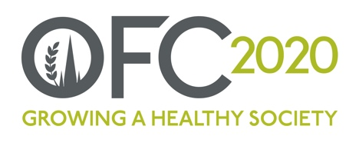

Issued by Jane Craigie Marketing. For further details or images, please contact marketing@ofc.org.uk or Rebecca on 07792 467730

Notes to Editors:
- For more information on the Oxford Farming Conference (OFC):
Website: www.ofc.org.uk
Twitter: @oxfordfarming
YouTube: OxfordFarmingConference
- The Council is made up of 10 voluntary directors.
- OFC is held over three days every January (7-9January 2020) and includes a vibrant programme of speakers, panel sessions, politics sessions and easy networking. The theme for 2020 is Growing a Healthy Society. www.ofc.org.uk/conference/2020
- OFC has been held in Oxford for 80 years and has established a reputation for strong debate and exceptional speakers.
- OFC is a charity that invests in the agricultural education and knowledge-sharing. It attracts over 600 delegates every year, including many people from the wider food chain, retail, NGOs, scientific organisations, media, policy-making bodies and governments from around the world.
- With HRH Princess Royal as its patron, OFC is a charity with a remit to educate and transfer knowledge in the agricultural sector. As part of its charitable undertakings, the OFC sponsors young people to attend the conference, to travel overseas and it seeks to develop emerging leaders.

